P234 T2

#include<iostream>

using namespace std;

class student

{

char name[20];

double id;

double score;

public:

void input()

{

cout << "name?";

cin >> name;

cout << "id?";

cin >> id;

cout << "score?";

cin >> score;

}

void output()

{

cout << "name:" << name << endl << "id:" << id << endl << "score:" << score << endl;

}

};

int main()

{

student A;

A.input();

A.output();

}

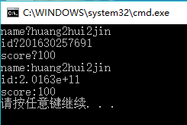

P242 T1

#include<iostream>

using namespace std;

class book

{

char bookname[30];

int number;

double price;

public:

void display()

{

cout << "the name of the book:" << " ";

cin >> bookname;

cout << "the number of the book:" << " ";

cin >> number;

cout << "the price of the book:" << " ";

cin >> price;

cout << "bookname:" << bookname << endl << "price:" << price << endl << "number:" << number << endl;

}

void borrow()

{

int \*n;

n = &number;

number=\*n - 1;

cout << "the lastest number:" << number;

}

void restore()

{

int \*n;

n = &number;

number = \*n + 1;

cout << "the lastest number:" << number;

}

};

int main()

{

int x;

book Mycpphmework;

Mycpphmework.display();

cout << "Do you want to borrow one or restore it?" << endl

<< "0 for borrow ;1 for restore" << endl;

cin >> x;

if(x)

Mycpphmework.restore();

else

Mycpphmework.borrow();

}

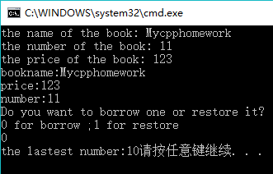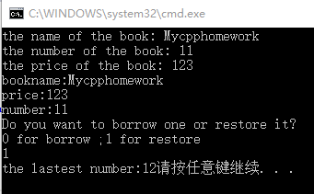

P242 T3

#include <iostream>

using namespace std;

class student

{

double score;

static double total;

static double count;

public:

void scoretotalcount(double s)

{

score = s;

total = total + score;

count++;

}

static double sum()

{

return total;

}

static double average()

{

return total/count;

}

};

double student::total = 0;

double student::count = 0;

int main()

{

int i, n; double s;

cout << "学生人数：";

cin >> n;

student a;

for (i = 1; i <= n; i++)

{

cout << "第" << i << "个学生的分数：";

cin >> s;

a.scoretotalcount(s);

}

cout << "总分：" << student::sum() << endl;

cout << "平均分：" << student::average() << endl;

}

